Coding of the Thesis
Access only possible after consultation of the author
Confidential: Access not possible

Industrial Project (PAIND)
First Name Last Name Author 1
Address
Telephone Number
Email address
Title of the work

Supervising Lecturer: (Academic Title) First Name Last Name

Lucerne University of Applied Sciences and Arts - School of Engineering and Architecture
Bachelor in Business Engineering | Innovation
Semester

Horw, Lucerne University of Applied Sciences and Arts – E&A
[Wählen Sie das Datum aus]

Declaration of authorship
„I hereby declare that I have written this thesis by myself without any help from others and without the use of documents and aids other than those indicated. All text excerpts used, quotations and contents of other authors are explicitly denoted as such. "

Horw, DD.MM.YYYY

(personal signature)
First and last name of author 1

Abstract in german AND english
(maximum 1000 characters for each language)
„In the management summary, the research problem, the relevant methodological steps, results and conclusions of the thesis are summarized on a maximum of three pages. The following question words give indications for the management summary: What? How? Why? What for? The action orientation (what needs to be done, managed) should build the focus. […]

The central question of the thesis is presented in the management summary. It should include results and recommendations for actions so that a hurried reader can find the most important statements of the text in a short form.
The management summary is not a personal comment. Formulations such as „We believe…“, „I am of the opinion that…“, etc. have to be placed in the preface only. The management summary is not an account of experiences about the examination of the topic“ (Ineichen, Wissenschaftliche Arbeiten konstruieren und gliedern (Eulenskript), 2010, p. 10).

The management summery should be a brief, comprehensive summary of your work. It is intended to allow readers to survey the contents of your article quickly. You should ensure that the first paragraph contains a statement of the topic of the dissertation and its significance, as well as an indication of the major outcome of your research. Abstracts are often placed on databases and the first paragraph may be all the user of such a database reads. Many database users will be reluctant to scroll down and read the whole of your abstract if their attention is not caught by the first paragraph.
Please note that an abstract/management summary is NOT the same as an introduction (Millar, Writing Dissertations: A Guide, 2012, p. 7).

Preface
(optional)
„Personal experiences with or thoughts about the thesis or thesis process can be written in the preface. For example:
- Thoughts about encountering the subject of investigation (topic, people, etc.)
- Personal experiences with the subject of investigation
- Generalization: classification of the subject into a wider context
[…]
- Acknowledgements” (Ineichen, 2010, p. 10).

This is an optional part of a dissertation which should not include the scientific or academic discussion of the topic. This is rather the place to include personal comments. These may be, for example, on:
• your choice of subject
• the place of your subject in your field of study
• your experiences during the process of producing your work
• the thanks you wish to express to those who have helped you (Millar, 2012, p. 7f.)

Table of contents
List of figures 6
List of tables 7
List of abbreviations and acronyms 8
1 Introduction 9
1.1 Starting situation 9
1.2 Research problem 9
1.3 Research objective 9
1.4 Structure of the thesis 9
2 Foundations 10
2.1 Foundations 2.1 10
2.2 Foundations 2.2 10
2.3 Interim conclusion 10
3 Methodology 11
3.1 Methodology 3.1 11
3.2 Methodology 3.2 11
3.3 Interim conclusion 11
4 Implementation 12
4.1 Implementation 5.1 12
4.2 Implementation 5.2 12
4.3 Interim conclusion 13
5 Results 14
5.1 Results 6.1 14
5.2 Results 6.2 14
5.3 Interim conclusion 14
6 Discussion 15
6.1 Discussion 7.1 15
6.2 Discussion 7.2 15
6.3 Interim conclusion 15
7 Final considerations and outlook 16
7.1 Summary of the results 16
7.2 Recommendations for the company 16
7.3 Future need for research 16
Bibliography 17
Appendix 18

List of figures
(optional)
Figure 1: TextTextText. 3
Figure 2: TextTextText 3

List of tables
(optional)
Table 1: TextTextText 3

List of abbreviations and acronyms
Abbreviations and acronyms can be used freely once the full form or proper name has been established.
HSLU | Hochschule Luzern
Lucerne UASA | Lucerne University of Applied Sciences and Arts

Introduction

Starting situation

Research problem

Research objective

Structure of the thesis

Foundations
„The foundations chapter informs about the current state of knowledge on which the thesis is based. Definitions, models and references to other scientific work and research results are part of this chapter“ (Ineichen, 2010, p. 12).
The chapter Foundations is based on a detailed literature research. It has to be taken into account that in general, publications from scientific journals have a higher credibility than other sources.

Your literature review should not be exhaustive, but rather authoritative. In other words, you should review the most important relevant work of others, the so-called core texts, and show that you have made use of the most pertinent desk-based sources. If you are reviewing the work of others, concentrate on their findings and conclusions, and any interesting methodological comparisons between their approach and yours. If you are detailing desk-based sources, then show in what way they are useful and make any necessary comments on their limitations (Millar, 2012, p. 8f.).

Foundations 2.1
(title needs to be adjusted)

Foundations 2.2
(title needs to be adjusted)

Interim conclusion

Methodology
„In this section, the research approach and the underlying methodology (qualitative, quantitative methods) are described. If different research approaches are possible, the choice should be justified.
This chapter shall, for example, include considerations about the necessity of a survey, the creation of a questionnaire as well as the choice of the sample.” (Ineichen, 2010, p. 12).

If your study involves a piece of interview-based or qualitative research, you should explain the questions you put, the selection of your sample of interview partners, and the analytical methods you intend to use. If, on the other hand, you are doing a quantitative survey, you should describe the survey instrument you used (e.g. the questionnaire), the size of the sample taken and the statistical methods you intend to apply.
With any method you describe you should include a brief discussion of its advantages and drawbacks. It is vital that your dissertation does not make claims or reach conclusions which go beyond what your methods and especially your sample warrant (Miller, 2012, p. 9).

Methodology 3.1
(title needs to be adjusted)

Methodology 3.2
(title needs to be adjusted)

Interim conclusion

Implementation
(Title can be adjusted. Example: Analysis)
„Here the analytical and conceptual investigation of the research questions is described. Depending on the topic, the length and grade of differentiation may vary” (Ineichen, 2010, p. 12).

Implementation 5.1
(optional; title needs to be adjusted)
Sample table and reference:
Group 1 | Group 2 | Group 3
Table 1: TextTextText

Implementation 5.2
(optional; title needs to be adjusted)
Sample figures:
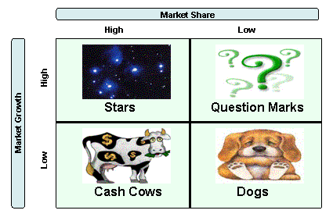
Figure 1: TextTextText.
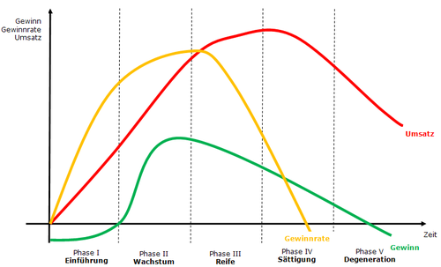
Figure 2: TextTextText

Interim conclusion

Results
(optional)
„In this chapter the results of the thesis are presented. It can be helpful to visualize the results with tables, diagrams, etc. Papers with practical orientation may also present and comment on measures to take and alternatives to be considered“ (Ineichen, 2010, p. 12).

In this section you should give the results of your research in such a way that they are clear and easily grasped overall by the reader. Tables, charts and other diagrammatic figures may help in achieving this. These should always be referred to and commented on in the text. Generally your results should be given in sufficient detail to support your conclusions (Millar, 2012, p. 9).

Results 6.1
(optional; title needs to be adjusted)

Results 6.2
(optional; title needs to be adjusted)

Interim conclusion

Discussion
(optional)

Discussion 7.1
(optional; title needs to be adjusted)

Discussion 7.2
(optional; title needs to be adjusted)

Interim conclusion

Final considerations and outlook

Summary of the results

Recommendations for the company

Future need for research

Bibliography
Backhaus, K. (2003). Industriegütermarketing (7. ed.). München: Verlag Vahlen.
Ineichen, M. (2010). Wissenschaftliche Arbeiten konstruieren und gliedern (Eulenskript). Luzern: Hochschule Luzern Wirtschaft.

Appendix
„The appendix shall contain all supplementary tables and references significant for the comprehensibility and foundation of the thesis. For example, when surveys are part of the thesis, the detailed tables from survey results or a questionnaire with summarized results would be included here.
The main text shall, at the appropriate places, contain references to the appendix“ (Ineichen, 2010, p. 17).

